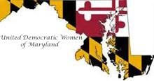
United Democratic Women of Maryland
Application for Membership

Application is hereby made for membership in the United Democratic Women of Maryland. I am a registered Democrat in the State of Maryland.

Name: _____________________________________________________________________

Address: ____________________________________________________________________

City/St/Zip: __________________________________________________________________

Phone Number: (H)__________________________ (C) _________________________

Email: __________________________________________

Do you belong to any Democratic Clubs? Please list:
_______________________________________________

County: _______________________________

Signature: __________________________________________ Date: __________ Annual

Dues:
$20 ($10 Young Dems or if joining after June 30th) ___________

Additional donation to UDWMD ___________

Total enclosed: ___________

Make checks payable to UDWMD and mail application and check to:
Jody Oliver, Treasurer
UDWMD
635 Arundel Street
Cumberland, MD 21502

Authorized by the United Democratic Women of Maryland, Jody Oliver Treasurer www.udwmd.org

